**roller conveyor systems**

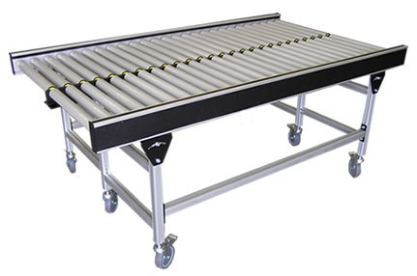

A conveyor roller system is a set of machinery which aids in handling of cargo on a large scale. Bulky stuff is transported quickly and easily with the help of such a system. Packaging, material handling, automobile manufacturing are some of the industries where these find application.

These systems have numerous inherent advantages which have made them immensely popular across all sorts of industries. These help in accurate and quick transportation of goods which otherwise, is labor intensive, costly and takes time. These are much safer to operate as compared to other systems like forklifts.

A conveyor roller can be immensely helpful in moving cargo of all types, weights, shape and sizes. With the use of advanced features, these ensure completely safe operation with complete removal of all chances of accident. In order to meet individual requirements, one can choose between fully automatic, mechanical and hydraulic systems for operation

**Take Up Conveyor**

http://fcp.imimg.com/gifs/zero.gifTake up conveyor are an integral part of our material handling equipment. We fabricate high quality of heavy duty take up screws for the conveyors. Compete care is given while fabricating and welding the screws to ensure that the screws are sturdy and are constantly in tension irrespective of the load direction.

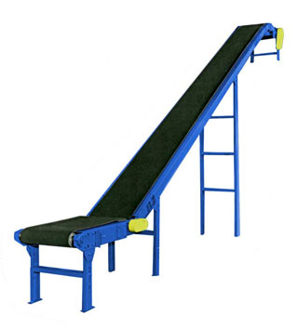

|  |  |  |  |  |  |  |  |  |  |  |  |  |  |  |  |  |  |  |  |  |  |  |
| --- | --- | --- | --- | --- | --- | --- | --- | --- | --- | --- | --- | --- | --- | --- | --- | --- | --- | --- | --- | --- | --- | --- |
|  | Slide bed belt conveyor system   |  |  |  |  |  |  |  |  |  |  |  |  |  |  |  |  |  |  |  |  |  | | --- | --- | --- | --- | --- | --- | --- | --- | --- | --- | --- | --- | --- | --- | --- | --- | --- | --- | --- | --- | --- | |  |  | Standard Specifications:     |  |  | | --- | --- | | ● | Belt: Green PVC 3 ply with stainless steel lacing or endless. | |  | Roller: S S roller 4”,saft & bearing housing s s 304    Geared motor: Bonfiglioli 1 hp | | ● | Supports: Stainless steel square tubular telescopic "H" supports, stationary or portable. | | ● | Drive: 1 HP(denfose ) heavy duty, motor-reducer drive with fully s s chain guard | | ● | Speed: Standard 50 feet per minute constant.  Other speeds and Optional Vari-Speed Drives also available. | | ● | Bearings: Nickel plated or Teflon coated housings  . | | ● | Take-Up: Stainless steel, telescoping quick release toggle. | | ● | Idlers: 1.9" diameter X 16 gauge stainless steel return idlers with stainless steel shafts and bearings. | |  |  | | |

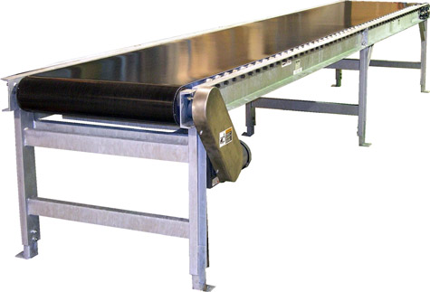

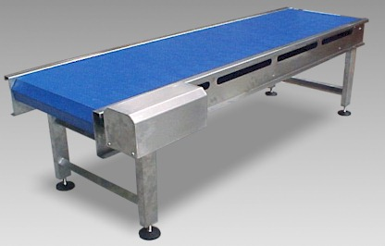

|  |  |
| --- | --- |
| ● | Belt: Blue PVC 3mm rubber with stainless steel lacing or endless. |

Bed: Heavy stainless steel channel slider bed

Drive: 1 HP motor